Semester Project Report of
Introduction to Cyber Security
Cognitive Metamorphic Cipher (CMC)



BSIET- FALL-(2023)

Submitted by
Momina Aftab FUI-FURC-F23BSET023
Iqra Pervez FUI-FURC-F23BSET014
Fatima Iqbal FUI-FURC-F23BSET010

Submitted to
Sir Usman Ahmed
Lecturer

Department of Engineering Technology
Information Engineering Technology Program
Foundation University School of Science and Technology

ABSTRACT
With the rapid growth of digital communication, securing sensitive information has become a critical challenge. This project presents a custom cryptographic system named Cognitive Metamorphic Cipher (CMC), developed using the PHP programming language. The system performs secure encryption and decryption of textual data by combining traditional cryptographic operations with cognitive-inspired parameters. Unlike conventional static algorithms, the proposed system dynamically generates encryption keys based on user-defined cognitive factors such as memory, adaptability, and attention. The algorithm applies block-based metamorphic operations that change with each data block, making the encryption highly unpredictable. Additionally, a secure password verification mechanism ensures that decryption is only possible with the exact credentials used during encryption. This project demonstrates an innovative approach to cybersecurity by introducing adaptive behavior into encryption techniques.

TABLE OF CONTENT
ABSTRACT i
TABLE OF FIGURES ii
1. INTRODUCTION 1
1.1 Problem Statement 1
1.2 Objectives 1
1.3 Proposed Solution 1
1.4 Scope of the Project 2
2. ALGORITHM DESCRIPTION 3
2.1 Keystream Generation 3
2.2 Encryption Algorithm 3
2.3 Decryption Algorithm 3
2.4 Block-Based Processing 3
2.5 Output Encoding & Validation 3
3. FLOW OF DIAGRAM 4
4. IMPLEMENTATION 6
4.1 Code Snippets 6
Snippet 1 Cognitive Factors Parsing: 6
Snippet 2 Weighted Drifted Calculation: 6
Snippet 3 generatedDriftedKey Method: 7
Snippet 4 applyBlockOperation Method: 7
Snippet 5 Encryption Logic: 8
Snippet 6 Decryption Logic: 8
4.2 Output……………………………………………………………………………………………9
5. CONCLUSION 17

TABLE OF FIGURES
Figure 1: Encryption Flow 4
Figure 2: Decryption Flow 5
Figure 3: Menu 9
Figure 4: Encryption Process-1 9
Figure 5: Encryption Process-2 10
Figure 6: Encryption Process-3 10
Figure 8: Encryption Process-4 11
Figure 9: Encryption Process-5 11
Figure 10: Decryption Process-1 12
Figure 12: Decryption Process-2 12
Figure 13: Decryption Process-3 13
Figure 15: Display Algorithm 14
Figure 18: Clear Verification Data From File 14

1. INTRODUCTION
Cryptography plays a fundamental role in protecting data confidentiality, integrity, and authenticity in modern information systems. Traditional encryption algorithms often rely on fixed keys and predictable structures, which can become vulnerable to advanced attacks over time. To address this limitation, this project introduces the Cognitive Metamorphic Cipher (CMC), a novel encryption technique that adapts its behavior dynamically during execution.
The system is implemented as a command-line PHP application that allows users to encrypt and decrypt messages securely. It uses cognitive factors provided by the user to influence key generation and encryption drift, resulting in a unique encryption pattern for every execution. The algorithm incorporates block-based processing, key mutation, and weighted drift calculations, making brute-force and pattern-based attacks significantly harder. This project highlights how adaptive and cognitive-inspired techniques can enhance traditional cryptographic systems.

Problem Statement
With the rapid growth of digital communication, sensitive data is increasingly vulnerable to unauthorized access and cyber threats. Traditional security methods often rely on static keys, making them predictable and easier to compromise. There is a need for a secure system that dynamically protects textual data during storage and transmission. This project addresses the challenge of ensuring confidentiality and safe data recovery through a custom cryptographic approach.

Objectives
The main objectives of this project are:
- To design a custom cryptographic algorithm using PHP
- To implement secure encryption and decryption mechanisms
- To generate a dynamic plaintext-based key influenced by cognitive factors
- To introduce metamorphic behavior through block-wise operation changes
- To ensure secure password verification before decryption
- To enhance data security using drift-based key mutation
- To provide a user-friendly CLI interface with detailed analysis options

Proposed Solution
The Cognitive Metamorphic Cipher system had the following proposed solution:
- Develop a PHP-based cryptographic system that supports both encryption and decryption of textual data.
- Implement a dynamic plaintext key generation mechanism based on user input to avoid static and reusable keys.
- Use block-based processing to enhance security and make the encryption process less predictable.
- Provide a simple command-line interface allowing users to easily select operations and enter data securely.
- Ensure accurate data recovery by applying reversible cryptographic logic during decryption.
- Enhance security by minimizing human readable patterns in the encrypted output.

Scope of the Project
The scope of this project is focused on demonstrating an adaptive cryptographic model suitable for educational and experimental cybersecurity applications. The system can be used for:
- Learning and demonstrating the design and implementation of custom encryption and decryption algorithms.
- Secure storage and safe transmission of textual data using dynamic key generation.
- Academic research in adaptive, cognitive, and lightweight cryptographic techniques.
- Development of command-line based security tools using PHP programming.
- Experimental alternatives to traditional static-key encryption methods for enhanced data confidentiality.
- Understanding block-based encryption mechanisms and reversible cryptographic operations.
- Training students in practical cybersecurity concepts and secure programming practices

2. ALGORITHM DESCRIPTION

2.1 Keystream Generation
- The algorithm generates a dynamic keystream using the user’s input string and security parameters.
- Each character is converted into its ASCII value and combined with its position index.
- This process ensures a unique keystream for every input.
- Static or reused keys are completely avoided to enhance security.

2.2 Encryption Algorithm
- The plaintext is divided into fixed-size blocks for structured processing.
- Each block is encrypted using reversible operations such as XOR and arithmetic transformations.
- The keystream is applied differently to each block, making the encryption metamorphic.
- The final output is converted into a secure encoded format.

2.3 Decryption Algorithm
- The ciphertext is processed using the same keystream and parameters used during encryption.
- Inverse cryptographic operations are applied block by block.
- Only correct parameters result in successful decryption.
- The original plaintext is accurately reconstructed.

2.4 Block-Based Processing
- Input data is divided into blocks to reduce predictability.
- Each block undergoes a slightly different transformation.
- This increases resistance against pattern-based attacks.
- It also improves algorithm efficiency.

2.5 Output Encoding & Validation
- Encrypted data is displayed in a human-unreadable encoded form e.g., hexadecimal.
- During decryption, input consistency is verified.
- Incorrect inputs result in failure messages.
- This ensures reliability and correctness of the system.

3. FLOW OF DIAGRAM
This diagram outlines a cognitive drift encryption process, where a user first provides an initial key and cognitive factors. The system generates a drifting encryption key that evolves with each data block, applying operations like XOR, addition, and subtraction while updating the key's position based on drift. Finally, all processed blocks are combined to produce the encrypted output, reflecting a dynamic, cognition-influenced cryptographic method.
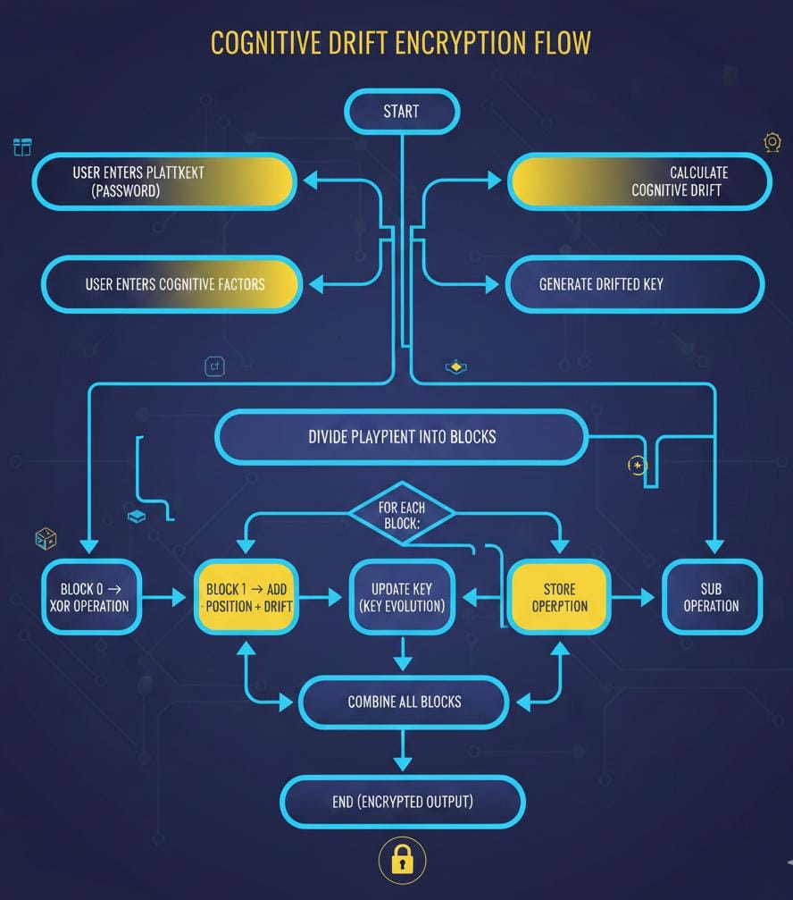
Figure 1: Encryption Flow
This diagram illustrates the cognitive drift decryption flow, which reverses the encryption process. It begins by converting the input ciphertext from hex into bytes, then regenerates the identical drifted encryption key using the same initial cognitive factors and key evolution logic. For each block of data, operations are reversed subtraction becomes addition, addition becomes subtraction, and XOR is reapplied, while the key updates in sync with its original drift path. Finally, all decrypted blocks are combined, and any padding is removed to recover the original plaintext.
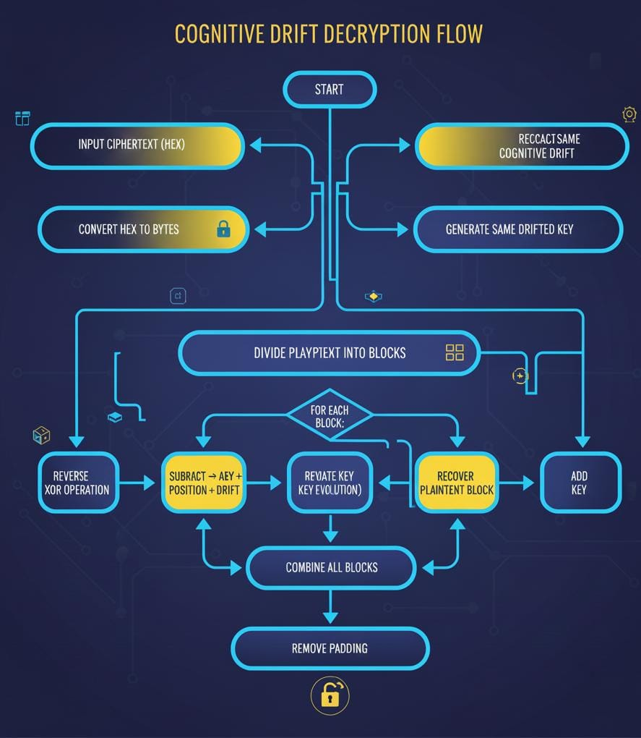
Figure 2: Decryption Flow

4. IMPLEMENTATION
The Cognitive Metamorphic Cipher (CMC) system is implemented using the PHP programming language and follows an object-oriented approach. The application runs in a command-line interface (CLI) and provides users with an interactive menu to perform encryption, decryption, view algorithm explanation, and manage verification data.

4.1 Code Snippets
Here are some important code snippets that describe the functionality of our project:

Snippet 1 Cognitive Factors Parsing:
private function parseCognitiveFactors($factorString, $requiredCount = null) {
$this->encryptionHistory[] = "=== Parsing Cognitive Factors ===";
$trimmed = trim($factorString);
if ($trimmed === "" && $requiredCount === null) { $numFactors = rand(3, 8);
$this->cognitiveFactors = []; for ($i = 0; $i < $numFactors; $i++) {
$this->cognitiveFactors[] = round(rand(0, 100) / 100, 2); }…….. $this->cognitiveFactors = $parsed;
$this->encryptionHistory[] = "Cognitive Factors: " . implode(", ", $this->cognitiveFactors);
return $this->cognitiveFactors; }
Explanation:
This function parses user-provided cognitive factors and ensures they are numeric values between 0 and 1. It also validates the exact number of factors if required. Parsed factors are stored for later drift calculation. This step ensures encryption adapts to user-specific cognitive input.

Snippet 2 Weighted Drifted Calculation:
private function calculateWeightedDrift() {
if (empty($this->cognitiveFactors)) return 0;
$weightedSum = $totalWeight = 0;
foreach ($this->cognitiveFactors as $index => $factor) {
$weight = $factor * $factor; $weightedSum += $factor * $weight; $totalWeight += $weight;……… return $this->weightedDrift;}
Explanation:
This snippet calculates the weighted drift, giving higher importance to larger cognitive factors. It modifies the encryption key dynamically, introducing variability in the cipher. Weighted drift is crucial for the metamorphic nature of the CMC system. This ensures that repeated use of the same key produces different results.

Snippet 3 generatedDriftedKey Method:
private function generateDriftedKey($baseKeyAscii) {
$this->encryptionHistory[] = "=== Generating Drifted Key ===";
$this->encryptionHistory[] = "Using Weighted Drift for key generation: " . sprintf("%.4f", $this->weightedDrift);
if (empty($baseKeyAscii)) { $this->driftedKey = [1, 2, 3, 4];
$this->encryptionHistory[] = "Warning: Empty password! Using default key: [1, 2, 3, 4]";
} else { $this->driftedKey = [];
foreach ($baseKeyAscii as $index => $keyByte) {
$drifted = ($keyByte + ($this->weightedDrift * 15)) % 256;
$this->driftedKey[] = intval($drifted); } }
$this->encryptionHistory[] = "Final Drifted Key: [" . implode(", ", $this->driftedKey) . "]";
return $this->driftedKey; }
Explanation:
This method creates a modified encryption key by incorporating the weighted drift, ensuring that the key adapts to cognitive factors. It prevents static key usage, enhancing security. A default key is used if the password is empty, maintaining system robustness. The drifted key is logged for verification and debugging.

Snippet 4 applyBlockOperation Method:
private function applyBlockOperation($charValue, $keyValue, $position, $blockIndex) {
switch ($blockIndex % 3) {
case 0:
$result = $charValue ^ $keyValue;
$this->encryptionHistory[] = " Operation: XOR ($charValue XOR $keyValue = $result)";
Break; ………case 2: $result = ($charValue - $keyValue + 256) % 256;
$this->encryptionHistory[] = " Operation: SUB ($charValue - $keyValue = $result mod 256)";
break;} return $result;}
Explanation:
This method performs different metamorphic operations XOR, ADD with weighted drift, or SUB—based on block index, making encryption dynamic. Each character is transformed uniquely, combining key, position, and drift influence. This variability strengthens security against pattern-based attacks. Logging provides a step-by-step encryption trail.

Snippet 5 Encryption Logic:
private function encryptForStorage($data, $key) {
$encrypted = ''; $keyLength = strlen($key);
for ($i = 0; $i < strlen($data); $i++) {
$encrypted .= chr((ord($data[$i]) + ord($key[$i % $keyLength]) + $i) % 256); }
return base64_encode($encrypted); }
Explanation:
This snippet encrypts sensitive data (like verification codes) for secure storage. Each character is modified using the key and its position, then encoded in base64. This adds an extra layer of security for stored information. It prevents plaintext recovery from files even if accessed.

Snippet 6 Decryption Logic:
private function decryptFromStorage($encryptedData, $key) {
$data = base64_decode($encryptedData);
$decrypted = ''; $keyLength = strlen($key);
for ($i = 0; $i < strlen($data); $i++) {
$decrypted .= chr((ord($data[$i]) - ord($key[$i % $keyLength]) - $i + 512) % 256); }
return $decrypted; }
Explanation:
This function reverses the storage encryption process. It decodes the base64 string and reverses the arithmetic and key operations. This ensures verification codes or sensitive data can be safely retrieved. Combined with encryptForStorage, it secures stored information against tampering.
4.2 Output
When the user selects the encryption process and enters the required input string along with security parameters, the system generates a dynamic plaintext key and processes the data block by block. After successful execution, the encrypted output is displayed on the screen in the form of a secure ciphertext, usually represented in hexadecimal format. The output also confirms the completion of encryption and shows relevant information such as block size and processing status. During decryption, the user provides the encrypted text and the same parameters used in encryption. The system verifies the inputs and then reconstructs the original message. Finally, the decrypted plaintext is displayed as output, confirming that the algorithm correctly restores the original data.
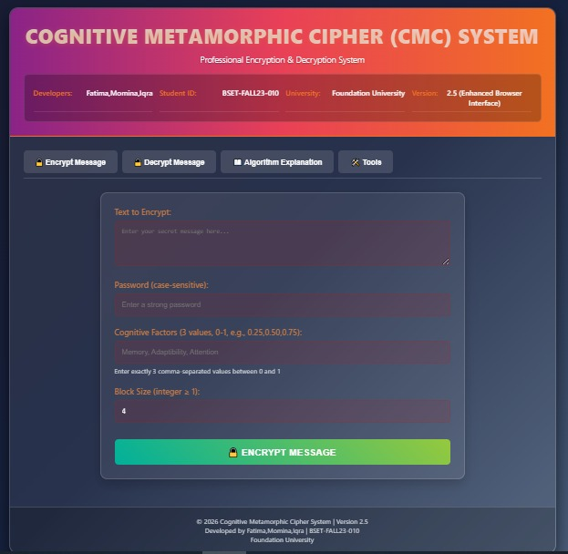
Figure 3: Menu
This is the Main Dashboard of our project, where the user had a choice to select one from the following, encrypt message, decrypt message, display algorithm explanation, clear verification data.
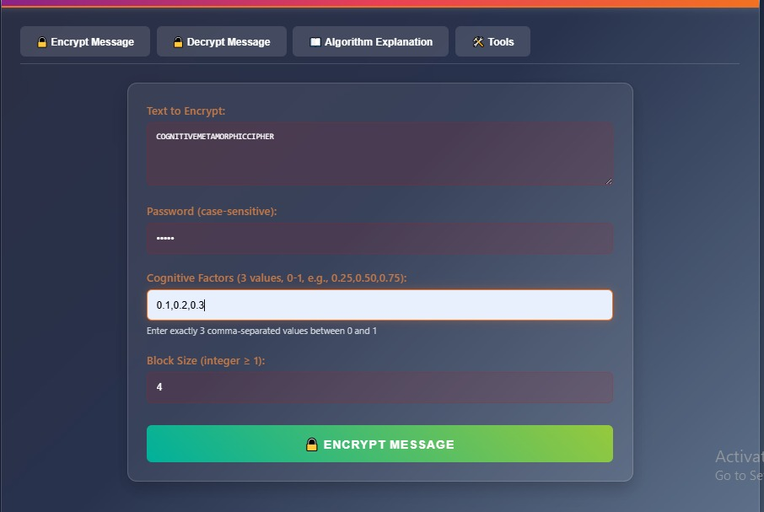
Figure 4: Encryption Process-1
In this screen user select the first option encrypt data, and then user have to enter a text for encryption then a password, and then enter any three cognitive factors, at last user have to enter the size of block.
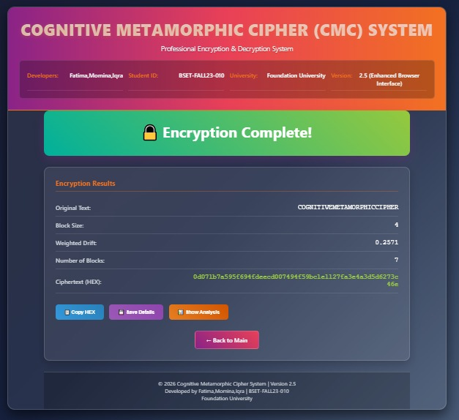
Figure 5: Encryption Process-2
This picture shows the successful execution of the encryption process in the Cognitive Metamorphic Cipher system, where the plaintext is securely transformed using block-based processing and weighted drift. The output displays key encryption details such as block size, drift value, number of blocks, and the final ciphertext in hexadecimal form, confirming successful encryption.
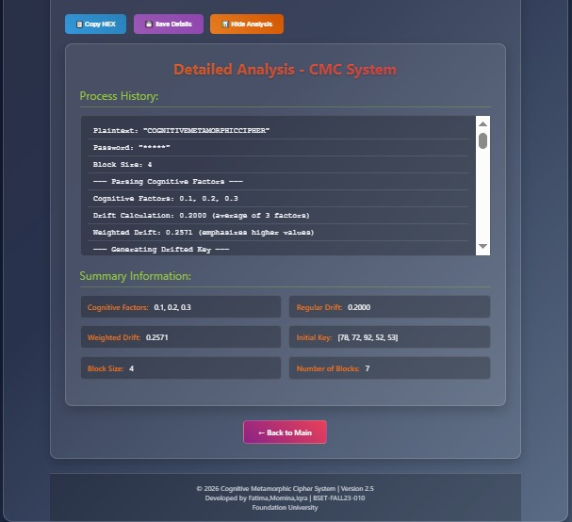
Figure 6: Encryption Process-3
This image presents the detailed internal analysis of the CMC encryption process, showing how cognitive factors are parsed, drift is calculated, and a dynamic keystream is generated. It also illustrates block division and metamorphic operations (such as XOR) applied step by step, providing transparency into how the final ciphertext is produced and also shows the final results and summary output of the CMC encryption process.
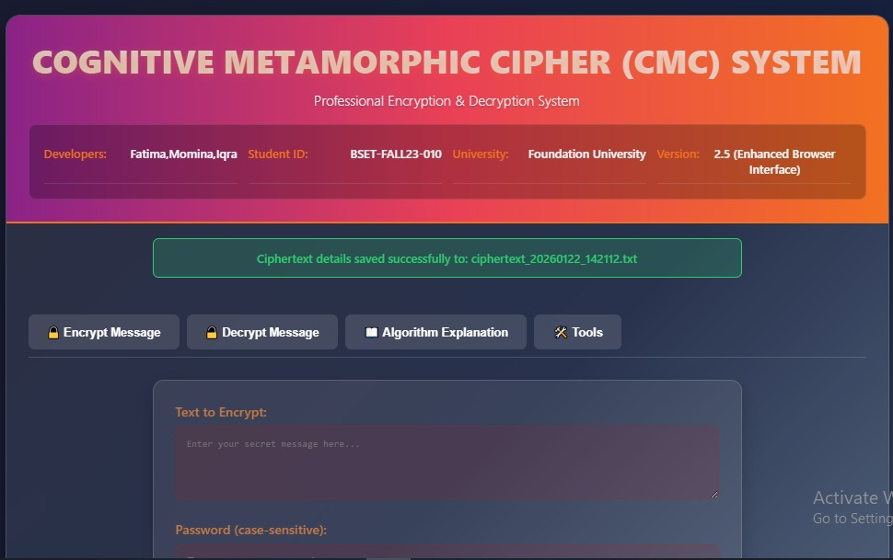
Figure 7: Encryption Process-4
This picture shows, if user want to save the encryption data or not, then user should press on “save details.
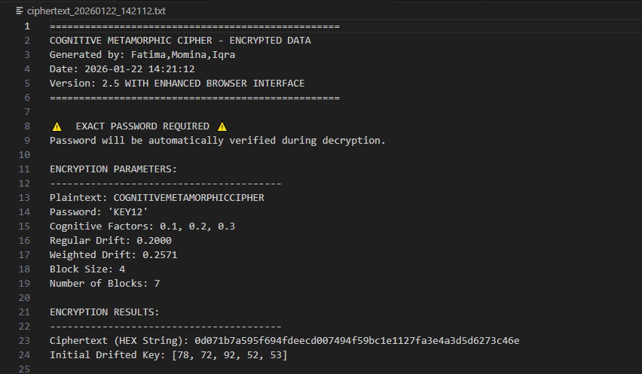
Figure 8: Encryption Process-5
This image shows an encrypted data file created using a “Cognitive Metamorphic Cipher,” along with its encryption settings. It displays the password, cognitive factors, block details, and the final ciphertext in hexadecimal form.
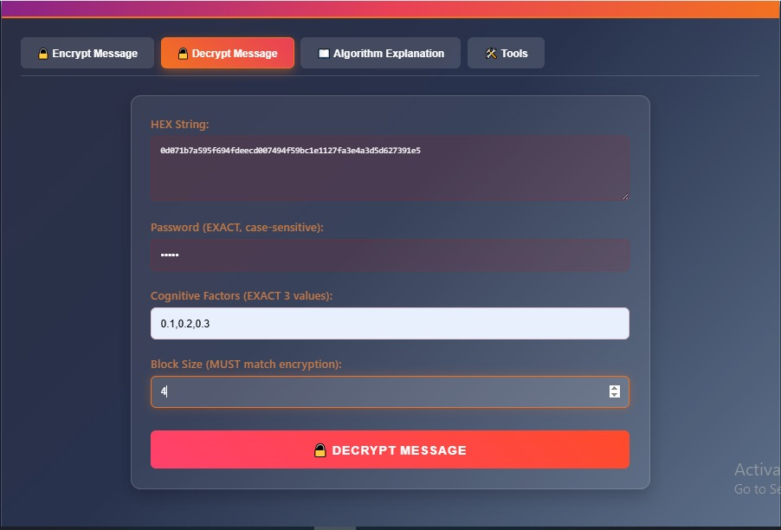
Figure 9: Decryption Process-1
In this screen user selects the second option Decrypt Message to decrypt the data. After select the choice Decrypt Message screen now user have to enter the following details in this screen for instance, Hexadecimal string, password, 3 cognitive factors, and at last the size of block.
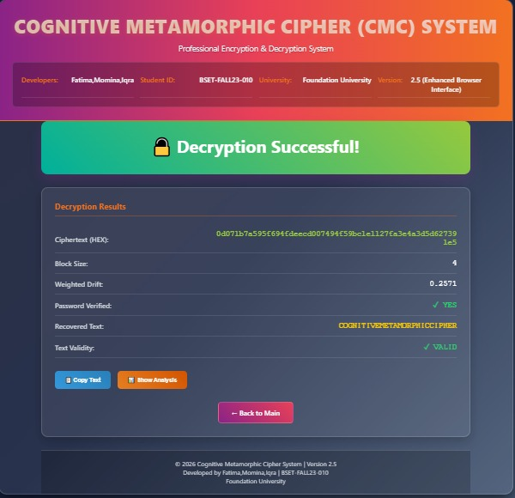
Figure 10: Decryption Process-2
The decryption was successful, resulting in the recovered plaintext "COSMITIVE METAMORPHIC CIPHER." The process used a block size of 4 and a weighted drift value derived from cognitive factors to transform the ciphertext. This indicates the original message was secured using a custom, cognition-based cryptographic algorithm.

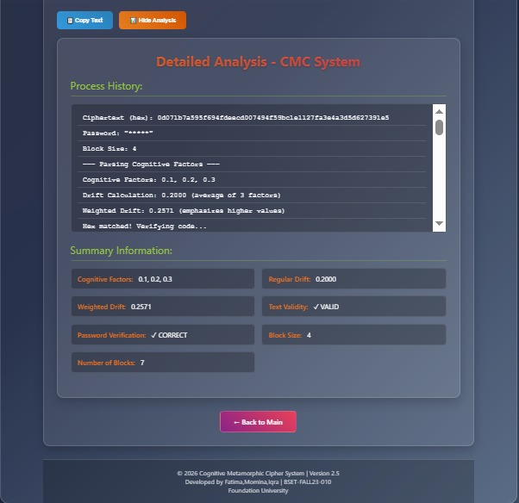
Figure 11: Decryption Process-3
Based on the image, a ciphertext is being decrypted using a password and a unique "cognitive metamorphic cipher" system. The process first verifies the encrypted data's integrity, then uses three cognitive factors (0.1, 0.2, 0.3) to calculate a "Weighted Drift" value of 0.2571. This drift value generates an 8-byte key, which is used to perform reverse XOR operations on blocks of data, successfully recovering the first block's plaintext values (67, 79, 71, 78).

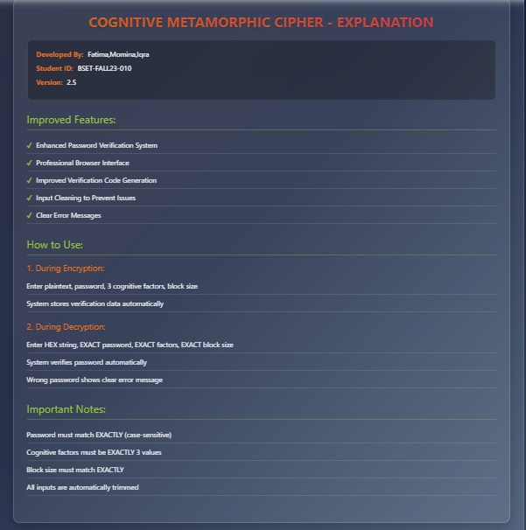
Figure 12: Display Algorithm
In this screen, if user wants to check the algorithm explanation, he selects the third choice Display Algorithm Explanation. After enter the third choice, user can see the explanation of algorithm for instance, developer name, their ID, and the version, and also the improved features of our project. The remaining data will show in this screen, for example, how to use our cognitive metamorphic cipher project during encryption and decryption, and the important notes as well which helps user to understand the project.
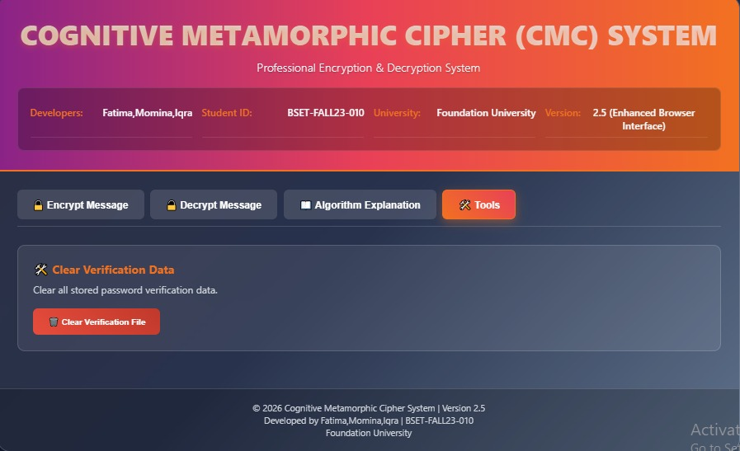
Figure 13: Clear Verification Data
In this screen, if user select the tools option, the system will display the message to user to clear verification data from file, if user enters, the system will clear the verification data from file then.

5. CONCLUSION
This project successfully demonstrates the practical implementation of a custom cryptographic algorithm using PHP for secure data handling. By integrating dynamic key generation and block-based processing, the system enhances data confidentiality and reduces the risk of unauthorized access. The dual functionality of encryption and decryption ensures reliable protection and accurate recovery of information. Overall, the project highlights the importance of cryptography in cybersecurity and shows how secure communication can be achieved through well-designed algorithms and programming techniques.
The Cognitive Metamorphic Cipher (CMC) project successfully demonstrates an innovative approach to encryption by integrating cognitive-inspired dynamics into cryptographic processes. By combining block-based metamorphic operations, drift-driven key evolution, and secure password verification, the system achieves a high level of unpredictability and security. The project not only strengthens understanding of cryptographic principles but also highlights the potential of adaptive algorithms in cybersecurity. Overall, this system serves as a strong academic contribution and a foundation for future research in intelligent encryption techniques.

